**Bachelor of Software Engineering Centre for IT Education (CITES) Department of Electrical and Computer Engineering The Open University of Sri Lanka**

**EEI3346- Web Application Development**

**Documentation for Mini Project**

**Name : MY.Azeez Ahamed**

**S.No: S92077064**

**Reg.No: 421437064**

**Problem**

The environmental problems facing Sri Lanka are serious. Over the previous five years, there has been a 30% increase in respiratory ailments due to air pollution from traffic and industry, which has resulted in a large spike in particulate matter and nitrogen dioxide. Rivers and lakes have been contaminated by industrial waste and agricultural runoff, while soil contamination from pesticides and chemicals is having an effect on groundwater and agriculture. Stress and hearing loss are brought on by noise pollution from traffic and urbanization, whilst animals are disturbed and the night sky is obscured by light pollution from excessive artificial lighting.

These issues are caused by lax waste management, fast industrial growth, and a lack of stringent emission restrictions. Sri Lanka has to solve these by enforcing laws governing noise control, lowering vehicle emissions, improving waste disposal, and promoting energy-efficient lighting to lessen light pollution.

Assessing Solutions: Utilizing this World Voice system, search for solutions with an emphasis on doable recommendations, legislative modifications, Green Live Tips, and neighborhood projects. The type of pollutants can determine different solutions.

• Air pollution: emission reduction, renewable energy, and air quality monitoring.   
• Water Pollution: Eco-friendly agriculture, pollution control, and water treatment.   
• Soil pollution: managing hazardous waste, sustainable farming practices, and soil repair.   
• Noise pollution: urban planning, soundproofing, and noise control laws.   
• Light pollution: energy-efficient lighting, dark-sky programmes, and artificial lighting laws.

Top of Form

**Architectural diagram of the system**

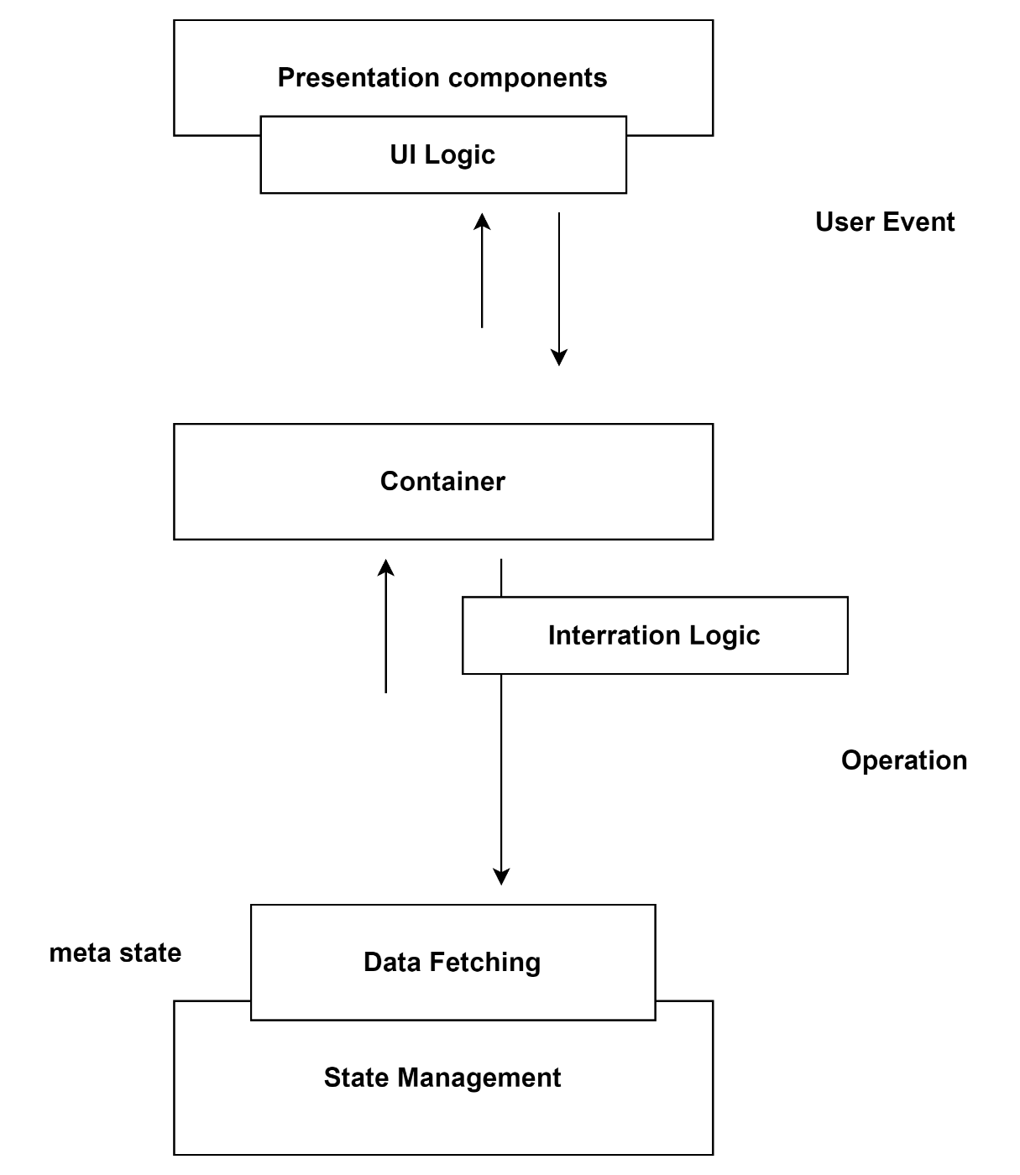

**Used web technologies and examples.**

1. Hyper Text Markup Language, or HTML   
    The common markup language for building websites and web apps is HTML. It establishes elements, organises content, and serves as the foundation for all web pages.
2. Cascading Style Sheets, or CSS   
    The appearance and styling of HTML elements are described by the style sheet language, or CSS. It manages responsiveness, colours, fonts, and layout.   
     
   3. Visual Studio Code

Visual Studio is an integrated development environment (IDE) created by Microsoft. It provides developers with a comprehensive set of tools for building various types of software applications, including web applications, desktop applications, mobile apps, and cloud-based services

4. Google chorme

**Test cases**

**Test Cases for the Navigation Bar**   
• Rendering of the Navigation Bar   
• Description: Verify that the navigation bar displays properly.   
• Steps:

1. Render the component using the relevant data and props.   
 2. Verify that all anticipated components—such as icons, links, and so on—are included.   
 • Anticipated Outcome: Every anticipated component appears in the navigation bar.   
 • Navigation via NavBar Link Check that the links in the navigation bar are functional.   
• Actions:

1. Select each link in the navigation bar.   
 2. Verify that the user has been forwarded to the appropriate page.   
• Anticipated Outcome: The navigation leads to the correct pages and functions as intended.

**Test Cases for Footers**   
Check the footer's functioning and content.

• Bottom Rendering   
• Description: Make sure the appropriate elements render in the footer.   
• First,

1.render the page with the footer.   
 2. Verify that all anticipated components—such as links and copyright—are visible.   
• Anticipated Outcome: Every anticipated component appears in the footer.

• Navigation via Footer Links   
• Description: Verify that the footer links function properly.  
• Procedure:   
  
1. Select every link found in the footer.   
2. Verify that the user has been forwarded to the appropriate page.   
• Planned Outcome: Links in the footer navigate to the appropriate pages as planned.

**Test Cases for Environmental Pollution Type and Solution Pages**   
• Information Page Rendering: Verify that all anticipated content appears on the information page.   
1.First, access the information page.   
2. Verify that all anticipated content—such as text, photos, and links—is visible.   
• Anticipated Outcome: The information page shows all of the anticipated content.

**Link Navigation on Information Pages**  
• Description: Verify that the information page's links are operational.   
• Actions:

1. Select each link on the details page.   
2. Verify that the user has been forwarded to the appropriate page.   
As anticipated, the links function properly and direct users to the appropriate pages.

**Conclusion**

* The environmental issues in Sri Lanka are significant, with air, water, soil, noise, and light pollution contributing to a range of health and ecological concerns. This app serves as a comprehensive platform to raise awareness, identify problems, and offer solutions for these pressing environmental challenges.